


ENECIQ
Functional Training
Show Cases

Prepared for
ENEC
25/03/2026
Version 0.1 DRaft

Prepared by
Sean Mc Guire

Contents
1. Contents 2
2. Introduction to this statement of work 3
3. Project Overview and Objectives 4
4. Methodology 5
5. Use Case 001: Improved R&D Research with many files 7
1. Demo Title 7
2. Microsoft Technology Components (Only Microsoft Stack) 7
3. Facilitator – 5-Step Demo Preparation & Flow 7
4. Training / Demo Files Required 8
5. How Participants Can Adapt This Demo to Their Own R&D Use Case 8
6. Use Case 002: xx 9
7. Use Case 002: xx 10
8. Use Case 002: xx 10
9. Use Case 002: xx 10
10. Use Case 002: xx 10
11. Use Case 002: xx 10

Methodology

Step 1: The use cases and proposed demos have been created on the base of preparation interviews prior to the actual onsite workshops. The information was collected on a Miro Whiteboard in interactive team meetings. Miro White Board Example
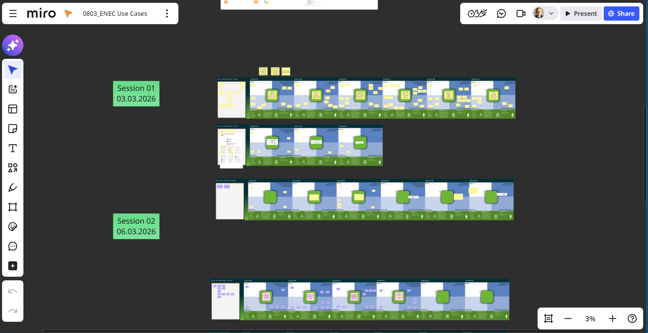
Step 2: ENEC subject matter experts share their ideas, pain points and examples where AI might be helpful in the future one a use case basis explaining who is the user, what the user wants to do, what problem the user has today and what the user expects from an AI-Enabled solution in the future.
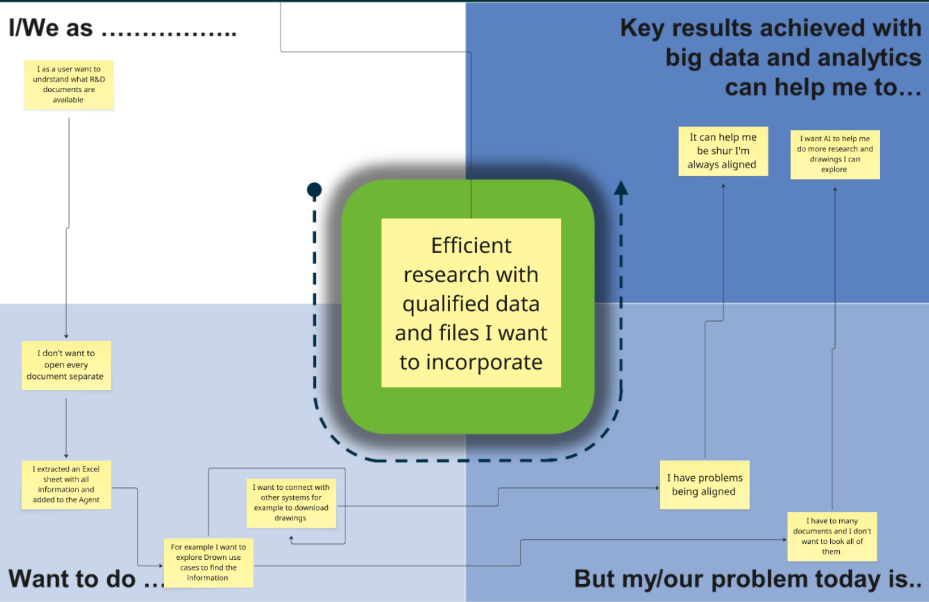
Step 3: The sticky notes and the conversation were extracted and summarized as individual use case clearly stating which user wants to do what.
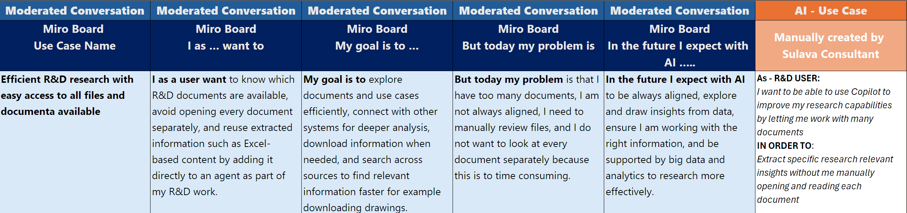
Step 4: The input is converted into a Demo proposal starting out with a Copilot suggestion and refining the details so they can be used in a fact-to-face training session, and the aim is to deliver demo examples that are inspirational for ENEC employees to use them in their daily work.
Copilot Prompt
Please suggest what kind of Copilot demo would most likely be interested in ENEC employees participating in a Copilot upskilling program who have shared the following USE Case in a pre-workshop interview.
##Scenario:
1. Participants are in a classroom training
2. Many of them have copilot experience but are no real experts
3. Participants should be able to understand how the demo is relevant to the use case
4. Participants should be able to understand how it saves time
5. Participants should be inspired to learn the skills it takes to solve similar problems
##Here is the Use case

Use Case 001: Improved R&D Research with many files
Miro Board  Use Case Name | Miro Board  I as … want to | Miro Board  My goal is to … | Miro Board  But today my problem is | Miro Board  In the future I expect AI ….. | Use Case  Summary
Efficient R&D research with easy access to all files and documenta available | I as a user want to know which R&D documents are available, avoid opening every document separately, and reuse extracted information such as Excel-based content by adding it directly to an agent as part of my R&D work. | My goal is to explore documents and use cases efficiently, connect with other systems for deeper analysis, download information when needed, and search across sources to find relevant information faster for example downloading drawings. | But today my problem is that I have too many documents, I am not always aligned, I need to manually review files, and I do not want to look at every document separately because this is to time consuming. | In the future I expect with AI to be always aligned, explore and draw insights from data, ensure I am working with the right information, and be supported by big data and analytics to research more effectively. | As - R&D USER:  I want to be able to use Copilot to improve my research capabilities by letting me work with many documents  IN ORDER TO:  Extract specific research relevant insights without me manually opening and reading each document

Demo Title
“R&D Research Copilot: From Document Chaos to Research-Ready Insights in Minutes”
Core message for participants:
“Instead of opening 50 documents, I ask Copilot once—and get structured, reusable research insights I can immediately work with.”

Microsoft Technology Components (Only Microsoft Stack)
- Microsoft Copilot (Microsoft 365)
- SharePoint Online (R&D document repository)
- Copilot Studio (AI Agent)
- Power Automate (optional, for download & reuse scenarios)
- Excel Online (structured data reuse)
- Microsoft Teams (demo interaction surface)

Facilitator – 5-Step Demo Preparation & Flow
Step 1 – Prepare the R&D Knowledge Base
- Create a SharePoint document library named R&D Knowledge Hub
- Upload mixed content:
  - Technical reports (Word/PDF)
  - Drawings (PDF)
  - Excel files with calculations, test results, or parameters
- Ensure metadata exists (Document Type, Project, Date, Discipline)
✅ This mirrors the “too many documents” pain point.

Step 2 – Create a Lightweight R&D Copilot Agent
- In Copilot Studio, create an agent named:
“R&D Research Assistant”
- Connect it to:
  - SharePoint Library
  - Excel files as structured data
- Enable grounded responses only from approved sources
✅ Participants see how they stay “aligned with the right information”.

Step 3 – Live Demo: Ask One Question Instead of Opening Files
In Teams or M365 Copilot, demonstrate prompts like:
“Which R&D documents are available for Project X related to thermal testing?”
“Extract key assumptions, test parameters, and results from all relevant documents.”
Copilot response:
- Summarizes across documents
- Lists sources
- Flags conflicts or outdated documents
✅ Clear, immediate time-saving moment.

Step 4 – Reuse Extracted Information (The “Aha Moment”)
Show Copilot:
- Extracting a table from multiple Excel files
- Reusing it by:
  - Adding it to the agent’s memory
  - Exporting it into a new Excel file
  - Using it as input for follow-up questions
Example prompt:
“Reuse the extracted test results and compare them to last year’s benchmarks.”

Step 5 – Download & Deepen the Analysis
Demonstrate:
- Asking Copilot to locate and download specific drawings
- Passing retrieved data into:
  - Excel for deeper analysis
  - A follow-up Copilot query (“What risks does this reveal?”)
✅ Connects research → analysis → decision support.

Training / Demo Files Required
Recommended demo set (small but realistic):
- 3–5 R&D technical reports (Word or PDF)
- 1–2 Engineering drawings (PDF)
- 2 Excel files with:
  - Test results
  - Parameters / assumptions
- Optional: one outdated or conflicting document to show alignment checks
✅ Keeps the demo realistic without overwhelming participants.

How Participants Can Adapt This Demo to Their Own R&D Use Case
Explain clearly that this demo is not about R&D only—it’s about a pattern:
What they can change:
- Documents
→ Replace with safety reports, regulatory filings, or project documentation
- Agent scope
→ Narrow to one project, one discipline, or one plant
- Prompts
→ Ask domain-specific questions (compliance, risk, optimization)
What stays the same:
- One trusted SharePoint source
- One Copilot agent
- One question instead of manual review
- Structured reuse of insights
Skills participants are inspired to learn:
- Writing better Copilot prompts
- Applying metadata for better AI grounding
- Creating simple Copilot agents
- Reusing AI outputs instead of repeating research
✅ This directly supports the learning objectives of the upskilling program.

Why This Demo Works for ENEC
- ✅ Directly maps to the exact phrasing of the R&D use case
- ✅ Shows relevance in under 5 minutes
- ✅ Demonstrates real time savings
- ✅ Encourages skills growth—not “magic AI”
- ✅ Scales from beginner to advanced without changing tools

Use Case 002: A perfect conversation with Copilot
Miro Board  Use Case Name | Miro Board  I as … want to | Miro Board  My goal is to … | Miro Board  But today my problem is | Miro Board  In the future I expect AI | Use Case  Summary
How to have a perfect conversation with LLM that helps me solve | I as an employee want to use AI and research-oriented LLMs effectively by understanding how to communicate with them and how to shape conversations so I can consistently get the right answers. | My goal is to efficiently communicate with AI by structuring prompts and conversations in a way that leads to accurate, relevant, and actionable outcomes. | But today my problem is that I do not always have an agent available, I lack guidance on how to optimize conversations, not everyone understands that good conversations take time, and not everyone is skilled at using AI properly. | In the future I expect with AI that all employees understand how to use AI properly and that users are guided to drive the correct conversations with LLMs in order to reliably obtain high-quality research results. | As - R&D USER:  I want a guided conversation how to use the LLM research capabilities to ask the right questions in an AI conversation  IN ORDER TO:  Get high-quality and reliable research results I can fully trust and use for guidance and decisions.

Recommended Copilot Demo
“From Vague Question to Trusted Research Outcome – A Guided Copilot Conversation”

Core Idea of the Demo
The demo shows a live, step-by-step conversation with Copilot where the facilitator intentionally starts with a poor prompt and then iteratively improves the conversation, using Copilot itself as a conversation guide.
Participants learn:
- That good AI outcomes are built, not asked once
- How to structure a research dialogue
- How guided prompting saves time and reduces rework
- What skills they need to practice to replicate this independently

Demo Scenario (R&D-Relevant and ENEC-Safe)
Context (spoken aloud):
“Imagine I’m an R&D employee at ENEC, preparing input for a technical decision or internal recommendation, but I don’t have an expert agent available.”

Research Topic Example (Safe, Non-Sensitive)
- Comparative analysis of emerging nuclear safety technologies
- Evaluation of international best practices (IAEA, WANO-style framing)
- Technology trend analysis for asset lifecycle, safety, or operations

Demo Flow (10–12 minutes, classroom-friendly)
Step 1 – Show the Problem (2 minutes)
Prompt (intentionally weak):
“Can you research best practices in nuclear safety technologies?”
Result:
Generic
High-level
Hard to trust
Not decision-ready
Teaching Moment:
“This is why many people say AI is not reliable.”

Step 2 – Introduce Guided Conversation (Copilot as Coach) (3 minutes)
Prompt:
“You are a research assistant. Before answering, ask me the clarifying questions you need to produce a high-quality, decision-ready research output.”
Copilot responds with:
Scope clarifications
Time horizon
Sources
Audience
Depth expectations
✅ Key Learning:
Good research starts with framing, not answers.

Step 3 – Shape the Conversation (3 minutes)
Facilitator answers Copilot’s questions live, showing:
- How to define role
- How to define output format
- How to define trust boundaries
Follow-up prompt:
“Based on my answers, propose a structured research plan before executing.”
Copilot provides:
Sections
Source types
Risks & assumptions
✅ Key Learning:
Participants see how AI can guide thinking, not replace it.

Step 4 – Trusted Research Output (3–4 minutes)
Execution prompt:
“Now execute the research using the agreed plan. Cite sources and clearly separate facts from assumptions.”
Copilot delivers:
Structured output
Clear reasoning
Transparent limitations
✅ Key Learning:
This feels usable, auditable, and decision-ready.

Why This Demo Resonates With ENEC Employees
Use Case Pain Point | How the Demo Solves It
“I don’t always have an agent available” | Copilot acts as a conversation guide
“I lack guidance on how to optimize conversations” | Demo shows how to ask for guidance explicitly
“Not everyone understands that good conversations take time” | Demo proves time saved through structure
“Users don’t fully trust AI output” | Shows source-driven, transparent reasoning
“Future expectation: everyone understands AI properly” | Teaches repeatable skills, not magic prompts

Skills Participants Walk Away Wanting to Learn
This directly inspires upskilling because participants see:
- How to ask Copilot to ask better questions
- How to build research conversations in stages
- How to control quality, confidence, and sources
- Why good prompting is a professional skill
You can explicitly call this out at the end:
“What you just saw is not one prompt — it’s a research conversation skill.”

Optional Enhancement (If Time Allows)
“Bad vs Good in Parallel”
- Left screen: one-shot prompt
- Right screen: guided conversation approach
Result difference is immediately obvious.

One-Line Value Statement for Participants
“Copilot doesn’t replace thinking — it scales structured thinking.”

Use Case 003: Effective Team Collaboration in evaluating a new project
Miro Board  Use Case Name | Miro Board  I as … want to | Miro Board  My goal is to … | Miro Board  But today my problem is | Miro Board  In the future I expect AI | Use Case  Summary
How can two teams better work together to clarify scope, project and | I as an end user want to get help from R&D when I have a problem, understand who is responsible, and collaborate effectively when it is unclear whether the topic belongs to technology or R&D. | My goal is to clearly define the problem by understanding whether it is a technology or R&D topic, create a proper problem statement, research who could solve it, and explore whether existing solutions or robots can be reused. | But today my problem is that it is often unclear who takes responsibility, whether R&D should hand over to technology, and whether the problem can be solved internally or requires an external vendor. | In the future I expect with AI that technology helps identify the best solution and vendor, suggests out-of-the-box solutions, supports better decision-making by increasing confidence and clarity of scope, and guides R&D projects toward the right implementation approach. | As - R&D USER:  I want help to make a decision if this is an R&D or technology topic and if the problem can be resolved internally or externaly  IN ORDER TO:  Identify the best solution and vendor, support better decision-making by increasing clarity of scope and guid R&D projects toward the right implementation approach

As a Copilot demo for this second ENEC use case, the most effective approach is to show Copilot acting as a neutral decision facilitator between R&D and Technology, not as a technical solver.
Below is a demo concept that mirrors real ENEC confusion, makes scope boundaries visible, reduces handover friction, and builds confidence in decision-making.

Recommended Copilot Demo
“From Ambiguous Problem to Clear Ownership and Solution Path”

Core Idea of the Demo
The demo shows how Copilot can:
- Help clarify whether a problem is R&D or Technology
- Turn a vague request into a shared problem statement
- Identify internal ownership vs. external vendor needs
- Reduce ambiguity and handover friction between teams
Copilot is positioned as:
A shared thinking and structuring partner, not “someone who decides for us”.

Why This Demo Fits ENEC Perfectly
This use case is not about answers — it’s about:
- Clarity
- Ownership
- Confidence
- Scope boundaries
That makes it ideal for a guided conversation Copilot demo instead of a feature demo.

Demo Scenario (Safe, Realistic, Relatable)
Spoken Context to Participants:
“I’m in R&D, I have a problem, but I’m not sure if this is something R&D should explore, Technology should implement, or a vendor should solve.”
Example Problem Statement (intentionally fuzzy):
“We need a smarter way to monitor and optimize equipment performance using automation and AI.”
✅ Everyone in the room will recognize this situation.

Demo Flow (10–12 Minutes)
Step 1 – Show the Current Pain (2 minutes)
Prompt (how people usually ask):
Is this an R&D topic or a technology implementation?
Copilot Result:
Vague
Non-committal
Not decision-ready
Teaching Moment:
“This is why responsibility stays unclear.”

Step 2 – Ask Copilot to Clarify the Problem (3 minutes)
Key Prompt:
Act as a joint R&D and Technology facilitator.
Before classifying this problem, ask the questions needed to:
1. Clarify scope
2. Identify responsibility
3. Decide if this is exploratory or implementation-driven
Copilot responds with structured questions:
Is the solution already known?
Is feasibility proven?
Is the goal discovery or rollout?
Are there existing platforms or robots?
Risk and uncertainty level?
✅ Key Learning:
Responsibility becomes clear only after clarification.

Step 3 – Co-Create a Clear Problem Statement (3 minutes)
Follow-up Prompt:
Based on my answers, rewrite this as a clear, decision-grade problem statement,
and classify it as:
• R&D
• Technology
• Hybrid
with justification.
Copilot Output:
Improved problem statement
Clear classification
Reasoned explanation
✅ Key Learning:
Copilot helps remove emotion and politics from scope decisions.

Step 4 – Internal vs External Decision (3–4 minutes)
Prompt:
Given this classification, help me decide:
• Can this be solved internally?
• Do existing tools or robots apply?
• When would an external vendor add value?
Present this as a decision matrix.
Copilot delivers:
Internal capabilities assessment
Reuse possibilities
Vendor involvement criteria
Risks of each option
✅ Key Learning:
Copilot increases confidence, not just speed.

Why Participants Will Instantly See the Value
Use Case Expectation | How the Demo Meets It
Unclear ownership | Clarified via guided questions
R&D vs Technology confusion | Neutral classification logic
Internal vs external decision | Structured decision framework
Better decision-making | Transparent reasoning
Scope clarity | Shared language and artifacts

Skills Participants Are Inspired to Learn
Participants will want to learn:
- How to ask Copilot to act as a facilitator
- How to externalize thinking into structure
- How to reduce friction between teams
- How to create decision-grade outputs, not chats
You can explicitly conclude with:
“This is how AI helps teams work together, not just faster.”

Optional Classroom Extensions

Option A – Role-Based Demo

One prompt framed as R&D
One as Technology
Copilot reconciles both perspectives

- Option B – Live Participant Input
Ask participants to shout out:
“What question is missing?”
Add it live → instant skill reinforcement

8. One-Line Takeaway for ENEC Employees
“Copilot doesn’t replace governance — it makes decisions clearer and faster.”

Use Case 004: Making good decisions without jumping to conclusions
Miro Board  Use Case Name | Miro Board  I as … want to | Miro Board  My goal is to … | Miro Board  But today my problem is | Miro Board  In the future I expect AI | Use Case  Summary
Make good decision in the early stage without jumping to conclusions | I as R&D want to make early project decisions based on data by aligning teams, involving the right stakeholders, and avoiding assumptions before committing to a specific direction. | My goal is to have structured discussions with end-users, manage projects effectively, follow technology readiness levels, and make informed decisions early even when projects are complex and uncertain. | But today my problem is that it is not always easy to understand whether something is an R&D project or not, ad-hoc requests and workshops create rework, early decisions lead to pitfalls, and unclear ownership results in fixes later. | In the future I expect with AI that big data and analytics help avoid ad-hoc work, support confident and timely R&D decisions, prevent long multi-year research paths, ensure quick alignment, and guide teams toward the right early-stage choices. | As - R&D USER:  I need support in making early project decisions based on data and by involving the right stakeholders  IN ORDER TO:  xx Avoid assumptions before committing to a specific direction and manage project effectively by understanding technology readiness and avoid pit-falls created by early decisions including avoiding unclear ownership.

As a Copilot demo for this third ENEC use case, the most compelling choice is a demo that positions Copilot as an early-stage decision guardrail — helping R&D teams slow down thinking without slowing down progress.
This demo should explicitly show how AI can prevent premature decisions, reduce rework, and introduce data-informed structure when uncertainty is high.

Recommended Copilot Demo
“Early-Stage Decision Guardrails: From Assumptions to Data-Driven Alignment”

Core Idea of the Demo
The demo shows how Copilot helps R&D teams:
- Avoid jumping to conclusions
- Structure early-stage discussions
- Identify right stakeholders early
- Align decisions with Technology Readiness Levels (TRLs)
- Prevent costly rework caused by unclear ownership
Copilot is framed as:
A decision-quality radar, not a decision maker.

Why This Demo Matches the ENEC Use Case
This use case is about decision discipline under uncertainty, not tools or execution.
Participants recognize:
- Ad-hoc workshops
- Early assumptions
- Late fixes
- Ownership confusion
- Multi-year research paths that could have been avoided
The demo shows how Copilot reduces those risks upfront.

Demo Scenario (Realistic and Relatable)
Spoken setup:
“We’re at an early stage of an idea. There’s pressure to move fast, but the risk is committing too early.”
Example Early-Stage Problem (intentionally ambiguous):
“We should explore AI-based optimization for critical asset planning.”
✅ Sounds promising
❌ High risk of assumptions

Demo Flow (10–12 Minutes)
Step 1 – Show the Risk of Premature Decisions (2 minutes)
Typical early prompt:
Is this a good R&D project and how should we proceed?
Copilot response:
Reasonable
Optimistic
Still assumption-heavy
Teaching insight:
“This looks good, but nothing here prevents us from making the wrong early decision.”

Step 2 – Ask Copilot to Act as an Early-Stage Decision Facilitator (3 minutes)
Key Prompt:
Act as an R&D early-stage decision facilitator.
Before recommending a direction:
• Identify assumptions
• Highlight uncertainties
• Ask data-driven questions
• Align with Technology Readiness Levels
``
Copilot responds by:
Surfacing hidden assumptions
Asking evidence-based questions
Mapping uncertainty zones
✅ Key Learning:
Copilot helps teams pause intelligently, not stall.

Step 3 – TRL-Based Classification and Ownership Check (3 minutes)
Follow-up Prompt:
Based on my answers, classify this initiative by:
• Technology readiness level
• R&D vs Technology involvement
• Ownership risks
• Recommended next decision gate
``
Copilot Output:
TRL estimation
Decision gates
Ownership clarity
“Too early to decide” flags
✅ Key Learning:
Participants see why early clarity prevents late fixes.

Step 4 – Stakeholder & Data Alignment (3–4 minutes)
Prompt:
For this maturity level:
• Who must be involved now?
• What minimum data is required before committing?
• What decisions should explicitly be deferred?
Present this as a simple decision checklist.
Copilot delivers:
Stakeholder map
Data expectations
Deferred decisions list
Risks of deciding too early
✅ Key Learning:
AI improves decision quality, not bureaucracy.

How This Directly Solves the Use Case
User Pain Point | How Copilot Helps in the Demo
Early assumptions | Explicit assumption surfacing
Ad-hoc workshops | Structured decision framing
R&D vs non-R&D confusion | TRL-based classification
Unclear ownership | Ownership risks identified early
Long research paths | Early go / no-go decision gates

Why Participants Will Be Inspired
Participants realize:
- They can use Copilot to defend better decisions
- AI helps justify not deciding too early
- Structure avoids rework
- Confidence comes from clarity, not speed
You can conclude with:
“Copilot helps you move fast without breaking things.”

Optional Classroom Enhancements

Option A – “Decision Too Early” Simulation

Ask participants: “What decision would you be tempted to make now?”
Let Copilot explain the risk

Option B – Red / Amber / Green Decisions
- Copilot classifies:
Decide now
Explore further
Explicitly defer

8. One-Line Takeaway for ENEC R&D
“Good early decisions are not about choosing fast — they are about choosing with clarity.”

Use Case 005: Is technology proposed suited for ENEC company
Miro Board  Use Case Name | Miro Board  I as … want to | Miro Board  My goal is to … | Miro Board  But today my problem is | Miro Board  In the future I expect AI | Use Case  Summary
Evaluate if technology proposed actually is applicable for a specific project | I as a standard owner want to ensure technology is evaluated against international standards, understand whether a solution such as a robot is applicable, and engage vendors only when appropriate. | My goal is to investigate solutions early, assess documentation quality, understand industry applicability (including nuclear context), and determine whether a solution fits ENEC-compliant working practices. | But today my problem is that vendor documentation is often insufficient, standards like ISO are not always adopted for the nuclear industry, solutions may take months to evaluate, vendors push incompatible technologies, and sometimes we must decide to build solutions ourselves. | In the future I expect with AI that technology supports compliance checks, accelerates research and validation, enables more technical conversations, helps assess vendor offerings quickly, and determines whether solutions are compatible or should be developed int | As - R&D USER:  xx I want to understand which international standards and nuclear specific industry applications are compliant with ENEC regulations  IN ORDER TO:  Nerrow down my vendor and solution evaluation time spend only on vendors and technology that qulify to ENEC standards and regulations and then make a decision if existing solutions are compatible or should be developed in-house by ENEC

As a Copilot demo for this ENEC use case, the highest-impact option is to show Copilot acting as a compliance-first technology evaluator — helping Standard Owners and R&D quickly disqualify non-applicable solutions before time is wasted.
This demo must make it clear that Copilot is not approving technology, but structuring and accelerating expert judgement in a nuclear-grade context.

Recommended Copilot Demo
“From Vendor Pitch to ENEC-Compliant Decision in Minutes”

1. Core Idea of the Demo
The demo shows how Copilot can:
- Evaluate vendor-proposed technology against international and nuclear standards
- Identify gaps in documentation quality
- Check industry applicability (generic vs nuclear)
- Support an early go / no-go / investigate-further decision
- Reduce evaluation cycles from months to hours
Copilot is framed as:
A standards-aware evaluation assistant, not a certifying authority.

2. Why This Demo Fits ENEC Standard Owners
This use case is about:
- Risk reduction
- Compliance confidence
- Vendor filtering
- Avoiding long evaluation loops
The demo explicitly mirrors the real frustration of:
- Vendor marketing slides
- Missing ISO / IEC alignment
- “This works in oil & gas” claims
- Late discovery of nuclear incompatibility

3. Demo Scenario (Highly Realistic)
Spoken setup:
“I’m a standard owner. A vendor proposes a robot / digital solution. Before engaging deeply, I need to know if this is even worth evaluating for ENEC.”
Example Input (simplified):
- Vendor solution description (short paragraph)
- Claims: “ISO-aligned”, “used in critical industries”
✅ Exactly what standard owners see every week.

4. Demo Flow (10–12 Minutes)
- Step 1 – Show Today’s Problem (2 minutes)
Typical question people ask Copilot today:
Is this technology applicable for ENEC?
Result:
Generic
Optimistic
Not standards-driven
Not decision-worthy
Teaching Moment:
“This does not reduce evaluation time or risk.”

- Step 2 – Ask Copilot to Act as a Compliance & Standards Evaluator (3 minutes)
Key Prompt:
Act as a nuclear-industry technology evaluation assistant.
Before recommending anything:
• Identify relevant international standards
• Identify nuclear-specific applicability requirements
• Highlight missing or weak vendor documentation
• Flag ENEC compliance risks
Copilot response includes:
- Relevant ISO / IEC categories
- Nuclear-specific considerations
- Gaps in vendor claims
- Early risk signals
✅ Key Learning:
Copilot filters, not just explains.

- Step 3 – Applicability & Qualification Check (3 minutes)
Follow-up Prompt:
Based on the provided information:
• Is this technology GENERIC, INDUSTRY-ADAPTABLE, or NUCLEAR-READY?
• What evidence would be required to upgrade its qualification level?
Explain the reasoning.
``
Copilot Output:
- Clear applicability classification
- Required proof gaps
- Documentation maturity assessment
✅ Key Learning:
Participants see how time is saved by disqualification, not approval.

Step 4 – Internal Build vs Vendor Decision Support (3–4 minutes)
Prompt:
Given the applicability and compliance gaps:
• Should ENEC evaluate this vendor further?
• Could this be adapted internally?
• Or should this be developed in-house?
Present as a decision logic table.
Copilot delivers:
- Decision logic
- Risk vs effort comparison
- Clear recommendation paths
✅ Key Learning:
Copilot helps decide where to invest effort, not just money.

5. Direct Mapping to the Use Case
Use Case Expectation | Demo Outcome
Standards clarity | Explicit ISO / nuclear framing
Vendor filtering | Early disqualification signals
Faster evaluation | No deep dives without evidence
Technical conversations | Standards-anchored discussions
Build vs buy decisions | Structured decision logic

6. Why Participants Will Be Inspired
Participants realize:
- They can push back on vendors with evidence
- AI enables more technical, confident conversations
- Evaluation time is reduced by asking better questions early
- Standards become usable, not bureaucratic
You can conclude with:
“Copilot doesn’t approve technology — it protects ENEC’s standards.”

7. Optional Enhancements (Very Powerful)

Option A – Vendor Claims vs Evidence
- Copilot splits:
Vendor statement
Required proof
Compliance gap

Option B – Nuclear Context Filter
- Ask Copilot:
Which parts of this solution are especially risky in a nuclear environment?

8. One-Line Takeaway for ENEC Standard Owners
“Copilot helps us stop evaluating the wrong technologies early.”

Use Case 006: Stakeholder and Compliance aspect of research
Miro Board  Use Case Name | Miro Board  I as … want to | Miro Board  My goal is to … | Miro Board  But today my problem is | Miro Board  In the future I expect AI | Use Case  Summary
I want to understand who are the stakeholders who will be required to include into the compliance assessement. | I as a project owner want to cross-check with the regulator, understand potential stakeholders, and review large amounts of documentation to identify any constraints or compliance requirements. | My goal is to identify all relevant stakeholders early, source and review documents for constraints, understand compliance questions, and ensure the right parties are involved in regulatory discussions. | But today my problem is that I have many documents to review, I do not always know which stakeholders are relevant for regulatory discussions, and stakeholder involvement depends on the specific solution being considered. | In the future I expect with AI that technology helps identify relevant stakeholders, supports regulatory analysis, and provides clarity on who needs to be involved based on the solution and c | As - R&D USER:  I want to know which stakeholders and compliance topics need to be discussed as part of my research work  IN ORDER TO:  Focus on relevant regulatory discussions and include the right stakeholders int the evaluation discussion based on regulatory asessement and internal guidelines.

As a Copilot demo for this use case, the most effective approach is to show Copilot acting as a regulatory-aware stakeholder and compliance discovery assistant — helping project owners systematically uncover who must be involved and why, based on the solution being assessed and the applicable regulations.
This demo should make it clear that Copilot does not replace regulators or compliance owners, but prevents blind spots early, when they are still cheap to fix.

Recommended Copilot Demo
“From Solution Idea to Complete Compliance & Stakeholder Map”

Core Idea of the Demo
The demo shows how Copilot can:
- Analyse a solution concept
- Identify relevant compliance domains
- Map mandatory and optional stakeholders
- Extract compliance topics from large document sets
- Reduce late-stage regulatory surprises
Copilot is positioned as:
A compliance scoping accelerator, not a compliance authority.

Why This Demo Fits ENEC Project Owners
This use case is about:
- Navigating complexity
- Avoiding missed stakeholders
- Reviewing too much documentation too late
- Entering regulator discussions unprepared
The demo makes visible something that is usually implicit knowledge held by only a few experts.

Demo Scenario (Highly Relatable)
Spoken setup:
“I’m a project owner. I have a solution idea, but I don’t yet know which compliance topics or stakeholders must be involved.”
Example Solution Description (simplified):
“Introduce an AI-enabled inspection robot to support maintenance planning inside controlled facilities.”
✅ Complex
✅ Cross-disciplinary
✅ Regulatory implications unclear

Demo Flow (10–12 Minutes)
Step 1 – Show the Current Problem (2 minutes)
Typical question today:
Who should I involve for compliance?
Result:
Generic lists
Over-inclusion or under-inclusion
No link to the actual solution
Teaching Moment:
“This is why people are often involved too late — or unnecessarily early.”

Step 2 – Ask Copilot to Identify Compliance Domains First (3 minutes)
Key Prompt:
Act as a regulatory and compliance scoping assistant for ENEC.
Based on this solution concept:
• Identify relevant compliance and regulatory domains
• Highlight nuclear-specific considerations
• Identify potential constraints
Do not list stakeholders yet.
Copilot responds with domains such as:
- Nuclear safety
- Cybersecurity / OT security
- Operational safety
- Data governance
- Vendor qualification
✅ Key Learning:
Stakeholders depend on compliance scope, not job titles.

Step 3 – Generate a Stakeholder Map Based on Compliance Needs (3 minutes)
Follow-up Prompt:
Based on these compliance domains:
• Identify mandatory stakeholders
• Identify advisory stakeholders
• Identify when the regulator must be involved
Explain why each is needed.
Copilot Output:
- Stakeholder roles (not names)
- Clear rationale per role
- Timing recommendations (early / later)
✅ Key Learning:
Copilot removes guesswork and politics from stakeholder inclusion.

Step 4 – Document & Constraint Discovery (3–4 minutes)
Prompt:
I have multiple internal guidelines and regulatory documents.
Help me:
• Identify which documents are most relevant
• Extract likely constraints and compliance questions
• Highlight topics that require regulator discussion
Summarize as a compliance checklist.
Copilot delivers:
- Prioritized document list
- Key compliance questions
- Regulator discussion triggers
✅ Key Learning:
AI turns document overload into focused preparation.

Direct Mapping to the Use Case
Use Case Challenge | Demo Outcome
Too many documents | Prioritized & summarized
Unknown stakeholders | Solution-specific mapping
Regulator uncertainty | Clear escalation triggers
Late compliance discovery | Early visibility
Inefficient discussions | Targeted conversations

Why Participants Will Be Inspired
Participants realize:
- They no longer need to rely solely on tribal knowledge
- Stakeholder identification becomes repeatable
- Regulatory discussions become focused and confident
- Compliance becomes a design input, not a late gate
You can conclude with:
“Copilot helps you ask the right compliance questions before it’s too late.”

Optional High-Impact Enhancements

Option A – “What Happens If We Miss This?”
Ask Copilot:
Which compliance risks might appear later if these stakeholders are not involved now?

Option B – Minimal Stakeholder Set
Ask:
What is the minimum stakeholder set needed to safely proceed to the next phase?

One-Line Takeaway for ENEC Project Owners
“Copilot helps ensure the right people are in the room before decisions are locked in.”

